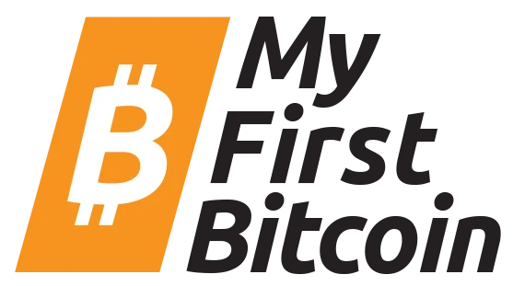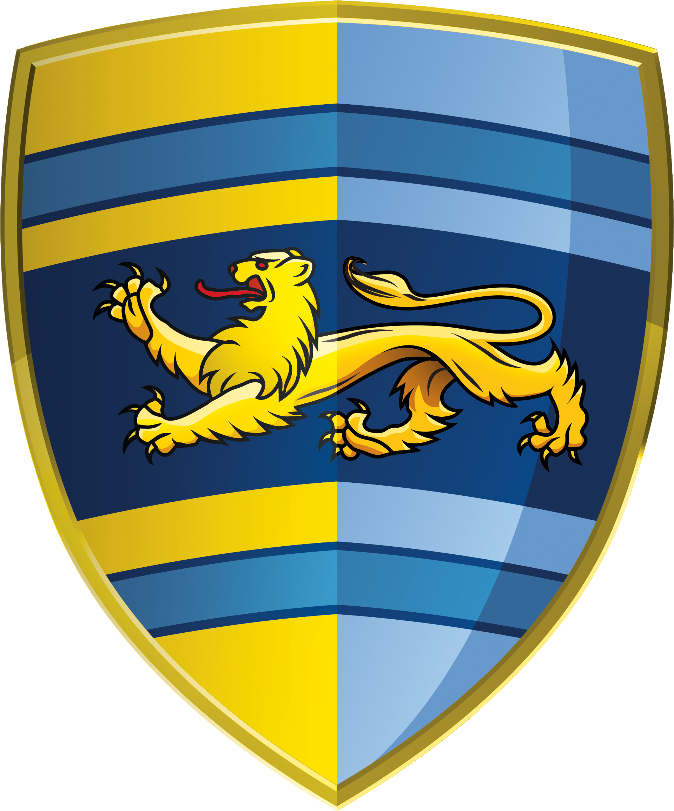

CERTIFICATE

Of Completion

This certifies that

Taylor Burgess

has successfully completed the training  
programme requirement for

# MY FIRST Bitcoin Diploma

Date

Instructor

21 August 2023

Huxley Darwin